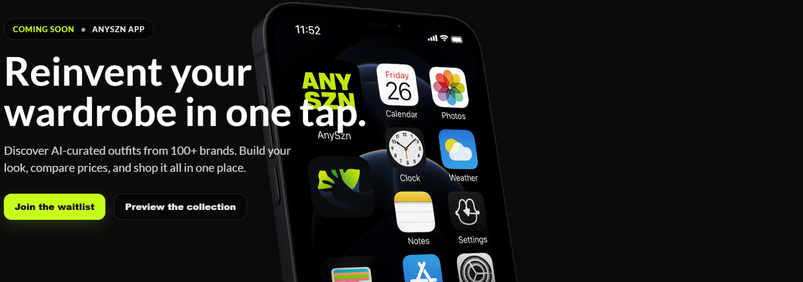
If we could move the phone over to the right a bit more so the writing doesnt go over the phone. So the "in one tap" bit isn't going over the phone.

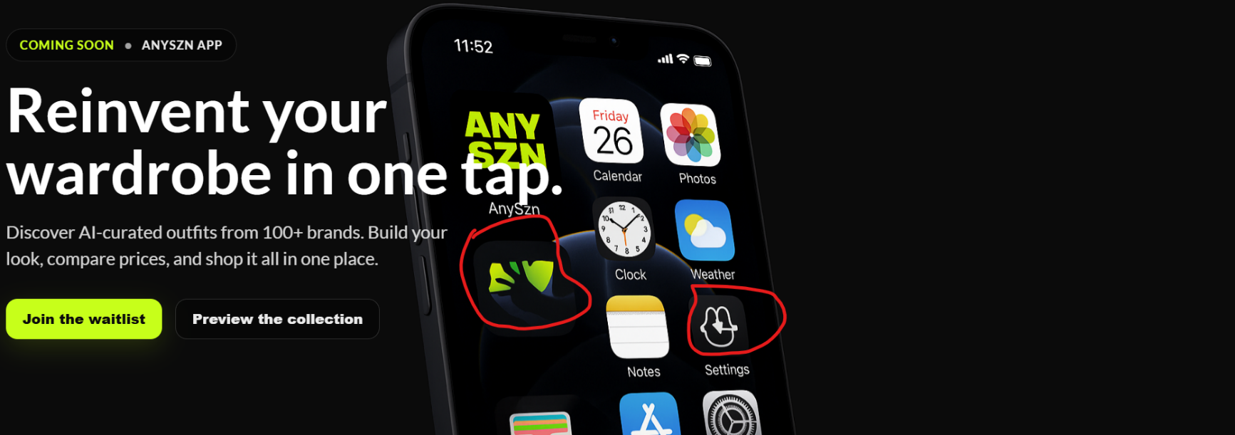
If we could move the phone over to the right a bit more so the writing doesnt go over the phone. So the "in one tap" bit isn't going over the phone.

also for the actual phone can we delete these app icons and just keep only the actual iphone app icons. I know I am being a bit picky but its just because I am a perfectionist.

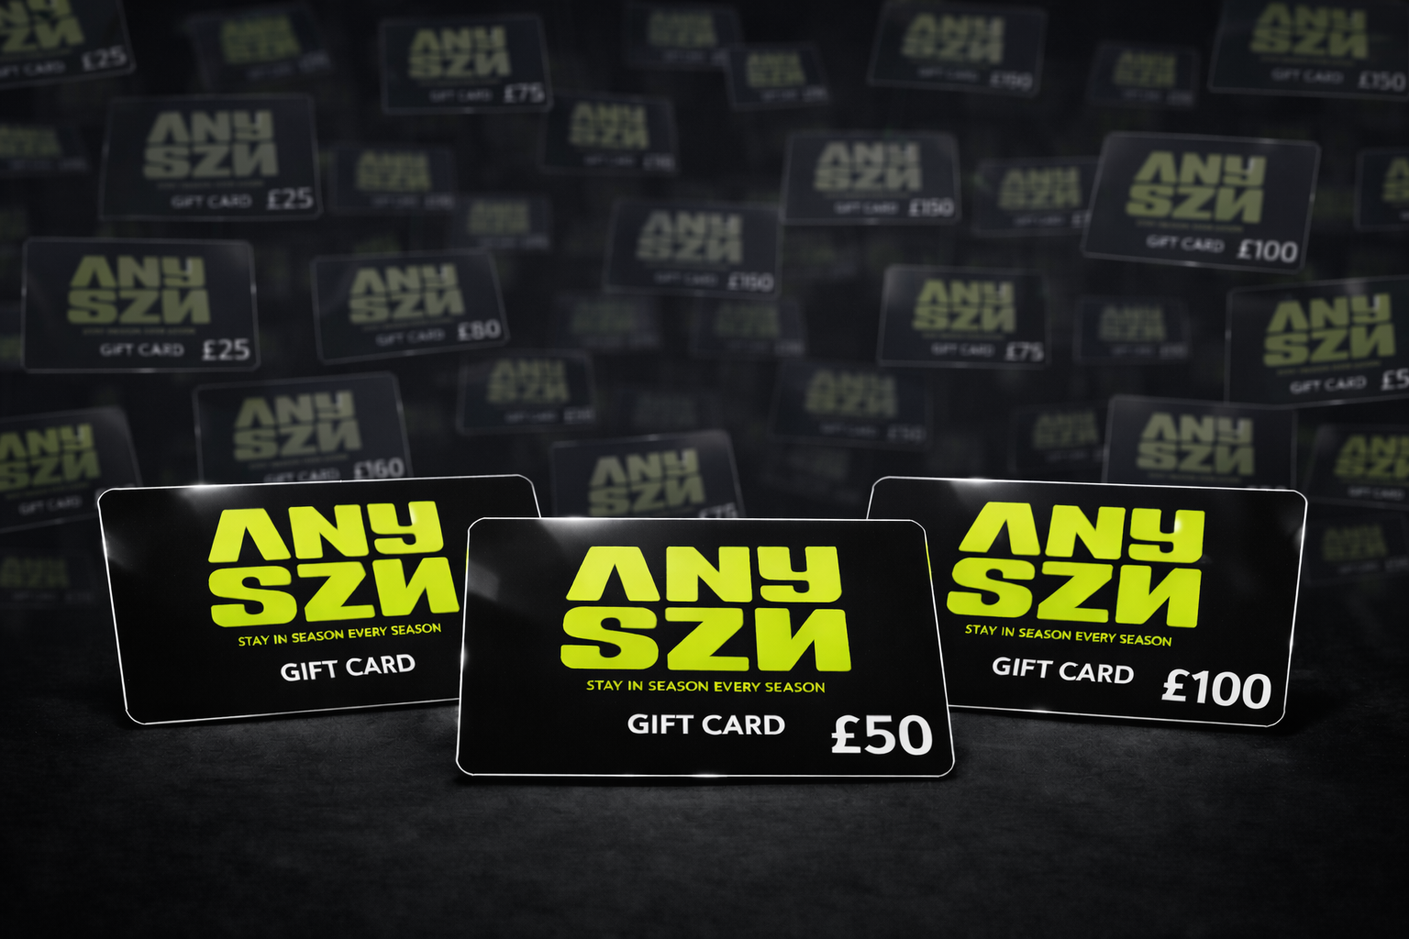
ANYSZN Gift Card Banner.

Support centre should be changed the FAQs

can we also remove exclusive offers and engage with followers.

FAQS Page
FAQs
Find quick answers to common questions about orders, shipping, returns and more.
Can I return an item if I’m not happy with my order?
Returns depend on the brand you ordered from. If the brand allows returns, we’ll happily assist you with returning the item directly back to that brand. Once the item has been returned and approved by the brand, you’ll receive your refund. All returned items must be unworn, unwashed, and have their original tags attached.
How long do orders take to ship?
Shipping times depend on your location and the brand your items are coming from, as each brand fulfils orders independently. Most orders are processed within a few business days. You’ll see an estimated delivery timeframe at checkout, and we’ll send you tracking details as soon as your order has been dispatched.
How much does shipping cost?
Shipping costs vary based on your location, order size, delivery option, and the brands you’re ordering from. If your order includes items from multiple brands, shipping costs may be higher due to separate deliveries. The final shipping cost will always be clearly shown at checkout before you confirm your order.
How do I know which size to order?
Each product page includes brand-specific sizing information to help you find the best fit. We aim to include a size guide for every product across different brands. If you’re between sizes, we recommend checking the measurements and fit notes, or contacting our support team for extra guidance.
Can I track my order?
Yes. Once your order has been shipped, you’ll receive a confirmation email with tracking details from the brand fulfilling your order. You can use this to follow your parcel’s journey and get the most up-to-date delivery information.

Shipping and Delivery Page
Shipping Information
Find the latest details on how we ship your orders, estimated delivery times, and how delivery charges are applied.
On this page, you’ll find important information about how shipping works on AnySzn. As a multi-brand marketplace, orders are fulfilled directly by the brands you purchase from. This means delivery times and shipping costs can vary depending on where each brand is based and where your order is being delivered.
How shipping works
AnySzn partners with independent fashion brands. Each brand is responsible for dispatching their own items. If your order includes products from multiple brands, those items may be shipped separately and arrive at different times.
Estimated delivery times
Estimated delivery times are calculated at checkout based on:
The location of the brand you’re ordering from
Your delivery address
The shipping method selected by the brand
Because brands may be based in different countries, delivery times can vary. You’ll always see an estimated delivery timeframe for each item before completing your order.
Delivery charges
Delivery charges are calculated and displayed at checkout as part of your order total. The final shipping cost depends on:
Your delivery address
The items in your cart
The number of brands you’re ordering from
If your order includes items from multiple brands, shipping costs may be higher due to separate deliveries. All applicable shipping fees will be clearly shown before you confirm your purchase.
Tracking your order
Once your order has been dispatched, you’ll receive tracking information from the brand fulfilling your order, allowing you to follow your delivery and stay up to date on its progress.

Returns & Refunds page
Returns & Refunds Policy
Find out when you can return items, what condition they need to be in, and how we process your refund.
As AnySzn is a multi-brand marketplace, return eligibility depends on the brand you ordered from. If the brand allows returns, we’ll happily assist you with returning the item and ensuring your refund is processed correctly.
Return eligibility
Items can be returned if the brand you purchased from accepts returns and the item meets their return conditions. To be eligible for a return, items must be in their original condition. This means clothing must be unworn, unwashed, and returned with all original tags and packaging still attached. Items must also be free from any signs of wear, makeup, fragrance, damage, or alterations.
Any return requirements or restrictions will be clearly communicated at the time of purchase.
How to return an item
If you need to return an item and are unsure how to proceed, please contact our customer support team. We’ll guide you through the process of returning the item directly to the brand and help ensure everything is handled smoothly.
Refunds
Once your returned item has been received and approved by the brand, your refund will be issued back to your original payment method.
Refund processing times may vary depending on the brand and your payment provider, but you’ll be notified as soon as your refund has been completed.

Track My order Page:
Track My Order
Deliveries are handled by a range of couriers, depending on the brand you ordered from and the delivery service they use.
Once your order has been dispatched, you’ll receive tracking details directly from the courier or from the brand fulfilling your order. This email will include the courier name and a tracking number, allowing you to follow your delivery.
If you haven’t received tracking details, please check any dispatch or shipping emails sent by the brand you ordered from. If you’re still unable to find your tracking information, our customer support team will be happy to help you locate it.
Choose your courier
Royal Mail
Use this option if your tracking details show Royal Mail as the courier.
Typical format: a mix of letters and numbers, for example AA123456789GB.
Track with Royal Mail
DHL
Choose this option if DHL is listed as the delivery partner.
Typical format: 10+ digits, or starting with JD followed by numbers.
Track with DHL
FedEx
Select this option if your order was shipped with FedEx.
Typical format: a 12–14 digit numeric code.
Track with FedEx
Evri
Use this option if your tracking details show Evri as the courier.
Typical format: usually 16 digits or a mix of letters and numbers.
Track with Evri
DPD
Select this option if your order was shipped with DPD.
Typical format: typically 14 digits.
Track with DPD
Need help tracking your order?
If you’re unsure which courier was used or can’t find your tracking number, please contact our customer support team. We’ll help you identify the correct courier and tracking details so you can stay updated on your delivery.

Payment method Page:
Please just remove:
- Diners Club | Credit Card | Accepted on many international orders, subject to issuer and region.

Also again Please remove Engage with followers page and faster checkout page.

